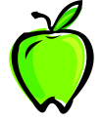
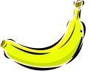
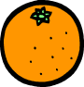
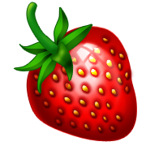

Favourite fruit is … | Pets in our class  Dog is ……… | Smarties in a tube  3 less than blue?
 | 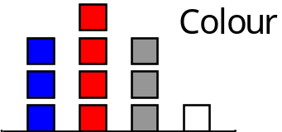Cars passing our school  Most cars are ……
  Round | ?
  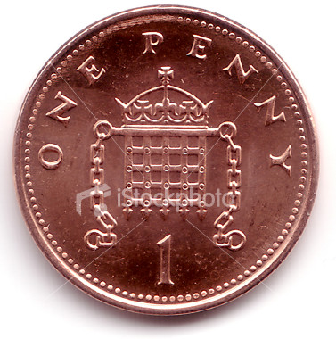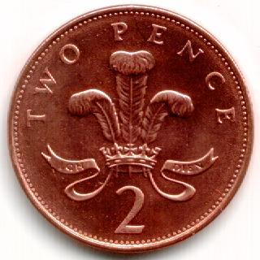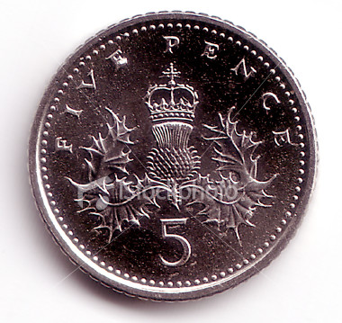 | 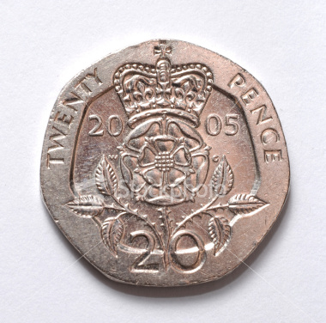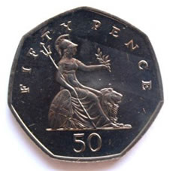
Favourite toys …  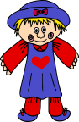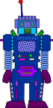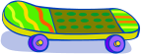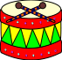 |  | Hair colour: Class 2  Most common is …
triangles
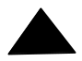

orange

not blue

brown
most common
banana
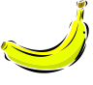

not round

red
least favourite
Hair colour
Blonde | ☺ ☺ ☺ ☺ ☺ ☺
Brown | ☺ ☺ ☺ ☺ ☺ ☺ ☺
Red | ☺ ☺
Black | ☺ ☺ ☺ ☺ ☺
Cat
Fish
Dog
Mouse

